Academic Year: 2025-26 | Year: Second Year | Semester: II
PRN No.: 1012411011 | Name: Riddhee Kulkarni
Subject: Python Programming
Assignment No.: 22
Date: 16/03/2026

Lab Assignment: 22
Aim:
To write a Python program demonstrating string methods such as upper(), lower(), split(), join(), count(), replace(), and find().

Objective:
- To understand various built-in string methods in Python.
- To perform different string manipulations using these methods.
- To analyze how strings can be modified and searched.

Theory:
Strings in Python provide many built-in methods for performing operations such as converting case, splitting text, replacing characters, and searching substrings.
Some commonly used string methods are:
- upper() – Converts all characters of the string into uppercase.
- lower() – Converts all characters of the string into lowercase.
- split() – Splits the string into a list of words based on spaces or a specified delimiter.
- join() – Joins elements of a list into a single string using a specified separator.
- count() – Returns the number of times a specified word or character appears in the string.
- replace() – Replaces occurrences of a word or character with another word or character.
- find() – Returns the index of the first occurrence of a word or character. If not found, it returns -1.

These methods help in efficient string manipulation and processing in Python programs.

Algorithm:
- Start the program.
- Accept a string from the user.
- Convert the string to uppercase using upper() and display it.
- Convert the string to lowercase using lower() and display it.
- Split the string into words using split() and display the list.
- Join the list of words using join() with - as a separator.
- Ask the user to enter a word to count and display its occurrence using count().
- Ask the user to enter a word to replace and the new word.
- Replace the word using replace() and display the result.
- Ask the user to enter a word or character to find.
- Use find() to display its index.
- End the program.

Pseudo Code:
START

INPUT string

PRINT string in uppercase
PRINT string in lowercase

SPLIT string into words
PRINT list of words

JOIN words using "-"
PRINT joined string

INPUT word to count
PRINT number of occurrences

INPUT word to replace
INPUT new word
PRINT replaced string

INPUT word/character to find
PRINT index using find()

END

Code:
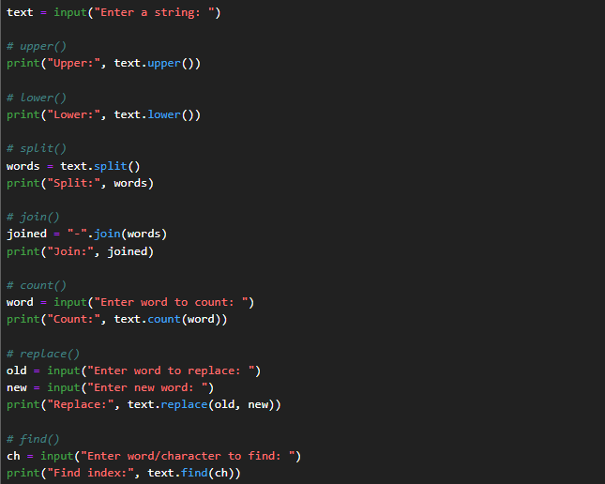

Output:
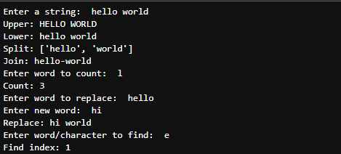

Conclusion:
Thus, the Python program was successfully executed to demonstrate various string methods such as upper(), lower(), split(), join(), count(), replace(), and find() for performing different string manipulation operations.

